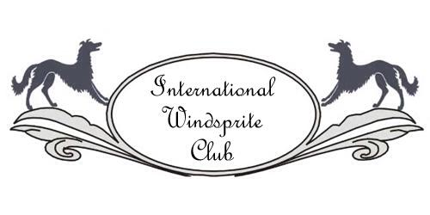

International Windsprite Club 2017 Membership Renewal
APPLICANT INFORMATION:
Membership Type (Circle or Highlight One): Individual Family Junior (age 10-17)
First Name: ____________________________ Last Name: _______________________________
Please fill out the following only if any information has changed:
Address: ________________________________________________________________________
City/State/Zip/Country: ____________________________________________________________
Best Phone: __________________ Other Phone: ___________________
E-mail: _____________________________________________________
Additional Names for Family Membership:
Name ________________________________Age ________ Email ______________________________
Name ________________________________Age ________ Email ______________________________
Name ________________________________Age ________ Email ______________________________
Note: Members with an email address will receive club communications via e-mail. Please make sure we have your current email.

Signature_________________________________________________ Date ______________________
If application is emailed, your name entered on the signature line will be considered an acceptable electronic signature.
Signature of Parent/Legal Guardian for Jr. member _______________________________________
FINAL DEADLINE FOR MEMBERSHIP RENEWAL IS JANUARY 31, 2017.
After that date, membership will lapse and reapplication will be necessary!
Single Membership Renewal Dues: US $20.00 ($16.00 if received by 31 Dec 2016)
Junior Membership Yearly Dues: US $10.00 ($8.00 if received by 31 Dec 2016)
Family Membership Yearly Dues: US $30.00 ($24.00 if received by 31 Dec 2016)

Please consider the inclusion of an additional monetary donation to the ILWC Health Fund.
The ILWC Health Fund is used for health-related research on LHWs.

Payment Method (Circle or Highlight One): CHECK PAYPAL (ilwc.treasurer@gmail.com)
Dues: $______
Health Fund Donation: $_______
TOTAL: $______
Mail Renewal Forms with check to:
ILWC c/o Donna DeVoist 6617 State Route 79, Chenango Forks NY 13746 USA
OR
Email completed renewal form to ddevoist@stny.rr.com and mail check to:
IWC c/o Donna DeVoist 6617 State Route 79, Chenango Forks NY 13746 USA
OR
Email completed renewal form to ddevoist@stny.rr.com and Pay by PayPal, by sending the payment to: ilwc.treasurer@gmail.com
Questions: ddevoist@stny.rr.com

