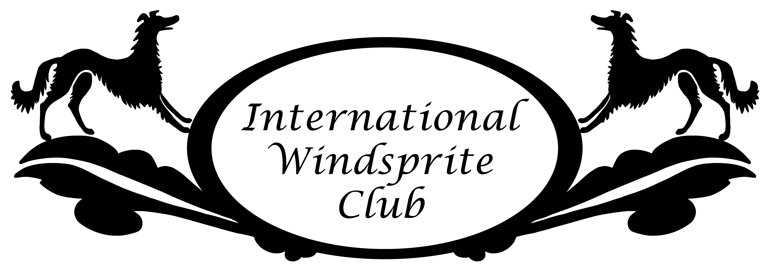
International Windsprite Club
Mid-Atlantic Spring 2017 Specialty Show
Entry Form (one dog)

Sat., May 27, 2017: agility & conformation; Sun., May 28, 2017 straight racing

Please mail all entries and fees to Patricia Conklin, 218 Yellow Barn Rd., Freeville, NY 13068
Email Tricia at yellowbarn@frontiernet.net with any questions regarding your entry but please do not email your entry.

Include check payable to "ILWC" (please note -- “ILWC”)

ENTRY FEES Early Bird Deadline: Postmarked by Friday May 12, 2017
Final Deadline: Postmarked by Friday May 19, 2017
Note that entry + entry fee must be postmarked to the show secretary on or before Friday May 19.
Electronic/emailed entries will not be accepted.

 | Non-member  Early Bird | Non-member  Entry Fee | IWC Member  Early Bird | IWC Member  Entry Fee
Conformation | $25 | $27 | $22 | $25
Agility | $15 | $17 | $12 | $15
Racing¹ | $15 | $17 | $12 | $15
Total | $55 | $61 | ($46) | ($55)
Package² | none | none | $41 | $49
Multi-Dog³ | none | none | $74 | $88

¹includes competitive racing and fun/practice runs ²if participating in all events ³maximum capped cost per owner for multiple entries

Saturday Lunch: $5 per person x ________ number of people: $___________
Saturday Dinner: $15 per person x ________ number of people: $___________
____________ = number of raffle tickets ($5 each or 5 for $20): $___________
Entry Fee: $___________
Total amount enclosed: $___________

If you wish to stay overnight on-site in your tent/van/RV, please circle tent van or RV (no hook-ups).

Owner Information

Owner(s) _______________________________________________________________________________________________________________

Address ________________________________________________________________________________________________________________

Phone #________________________________________ Email __________________________________________________________________

Dog Information
Variety: (Circle one) Windsprite-Longhair Windsprite-Smooth % Windsprite (≥50% Windsprite)*
*will be judged with Longhair or Smooth Windsprites depending on coat type (please write-in coat type)

Intact Altered (circle choice)

Registered Name of Dog _____________________________________________________________________________________
Call name _____________________________________________________________________________________
IWC Registration # _______________________________________________________ Breeder __________________________
Gender: Male Female (circle one) Date of Birth ______________________
Sire’s Registered Name___________________________________________________________________________________________
Dam’s Registered Name__________________________________________________________________________________________

Entry - Classes Entered (circle choices):

Junior Showmanship:
Pre-Jr. 6-10 yrs | Jr. 11–14 yrs | Sr. 15-18 yrs

Conformation:

Puppy:
3 to < 6 mos. | 6 to <9 mos. | 9 to <12 mos.
12 to <18 mos. | Open | Bred by Exhibitor
Veteran (9+ yrs.) | Grand Champion | Best of Breed

Agility: Circle jump height: 8 12 16 20 24 & also circle class (pup, reg, vet) & level for each
Pup (6- <15 mo)/Beg(all level 1) | Regular: | Veteran (9+ yrs.):
Standard | Level 1 2 3 (circle level) | Level 1 2 3 (circle level)
Fullhouse | Level 1 2 3 (circle level) | Level 1 2 3 (circle level)

Straight Racing (please circle run entered):
Puppy (<12 mo) Individual Run | Standard – Competitive Run | Veteran (9+yrs) Competitive Run
 | Standard – Individual Run | Veteran (9+yrs) Individual Run

AGREEMENT
I (we) agree that the club holding this conformation show or obedience trial or agility trial or lure coursing trial has the right to refuse this entry for cause that the club shall deemed to be sufficient. In consideration of the acceptance of this entry and of the holding of the conformation show or obedience trial or agility trial or lure coursing trial associated event and the opportunity to have the dog judged and to win prize money, ribbons or trophies. I (we) agree to hold this club, its members, directors, governors, officers, agents, superintendents or show secretary and the owner or lessor of the premises and any employees or assigns of the aforementioned parties harmless from any claim for loss or injury that may be alleged to have been caused directly or indirectly to any person or thing by the act of this dog while in or upon the conformation show or obedience trial or agility trial or lure coursing trial grounds or show-associated event grounds, or near any entrance thereto, and I (we) personally assume all responsibility and liability for any such claim; and I (we) further agree to hold the aforementioned parties harmless from any claim for loss of this dog by disappearance, theft, death or otherwise, and from any claim for damage or injury to the dog, whether such loss, disappearance, theft damage or injury be caused or alleged to be caused by the negligence of the club or any of the parties aforementioned or by the negligence of any other person, or other cause or causes.

I (we) hereby assume the sole responsibility for and agree to indemnify and save the aforementioned parties harmless from any and all loss and expenses (including legal fees) by reason of the liability imposed by law upon any of the aforementioned for damage because of bodily injuries, including death at any time resulting there from, sustained by any person or persons, including myself (ourselves) or on account of damage to property, arising out of or in consequence of my (our) participation in this conformation show or obedience trial or agility trial or lure coursing trial or show-associated events however such injuries may have been caused or may be alleged to have been caused by negligence of the aforementioned parties or any of their employees or agents, or any other persons.

Signature: ___________________________________________________________ Date: ________________________________

